 |  | Website project proposal for  MORULA VIEW CAR WASH, STREET FOOD & YEAR-END EVENTS  Siyabonga Mangwane  ST 10521698 Website Project Proposal

2. WEBSITE GOALS AND OBJECTIVES

Table of Contents
1.ORGANISATION OVERVIEW 2
2.WEBSITE GOALS AND OBJECTIVES 3
3.CURRENT WEBSITE ANALYSIS 4
Analysis Chain (Observation → Problem → Impact → Website Response): 4
4.PROPSED WEBSITE FEATURES AND FUNCTIONALITY 5
WIREFRAMES (STRUCTURAL LAYOUT PLANS) 6
5.DESIGN AND USER EXPERIENCE 8
6.TECHNICAL REQUIREMENTS 9
7.TIMELINE AND MILESTONES 10
8.BUDGETS 11
9.REFERENCES 12

1.ORGANISATION OVERVIEW

THE ORGANISATION NAME IS: MORULA VIEW CAR WASH, STREEST FOOD
Established in 2021, Morula View Car Wash & Street Food has grown into a trusted local hub in “LEFISO VILLAGE (LEFISO MAIN ROAD BEFORE TAXI RANK) IN THE NORTHWESTEN OUTSKIRTS OF MPUMALANGA
Morula View Car Wash & Street Food is an established multi-service local hub operating in Lefiso Village. Founded in 2021, the business integrates professional automotive care with convenient, high-quality street food catering. Beyond day-to-day operations, the venue serves as a prominent community venue for regional culture and entertainment.
Core Operations & Offerings
Automotive Detailing Services: Provides comprehensive vehicle cleaning options ranging from basic exterior wash packages ("Wash & Go") to full-service interior and exterior deep cleaning ("Executive Valet").
Street Food & Catering: Offers freshly prepared, affordable local fast food—including customized Kotas, chips, snacks, and beverages—allowing customers to dine comfortably while waiting for vehicle services.
Community Events & Culture: Hosts major annual culture and entertainment gatherings, most notably the annual year-end Morula Epic 29 (Ditrupa Edition). This event showcases traditional Ditrupa cultural performances alongside local musical artists to promote community unity and celebrate local heritage.
Business Mission & Strategic Goals
The mission of Morula View Car Wash & Street Food is to deliver reliable, top-tier vehicle detailing alongside delicious local food in a welcoming environment. The business strives to entertain, inspire, and unite the community through social gatherings and cultural event hosting. Establishing an official digital presence aims to bridge the gap between physical operations and online customer engagement.
Target Audience Breakdown
Primary Audience (Car Care): Local private vehicle owners, taxi operators, and commuters along Lefiso Main Road seeking reliable, efficient vehicle cleaning services.
Secondary Audience (Dining): Neighbourhood residents, local workers, and waiting car wash customers looking for quick, quality street food options.
Tertiary Audience (Event Attendees): Youth, music enthusiasts, and cultural supporters across Lefiso Village and neighbouring Mpumalanga/North-West regions seeking information on the Morula Epic 29 event

2.WEBSITE GOALS AND OBJECTIVES
Overall Project Goal: To design and build a clean, responsive, multi-page static HTML website for Morula View Car Wash & Street Food (established in 2021) that establishes an official digital presence. The website will showcase professional vehicle cleaning services, local street food offerings, and promote their flagship annual year-end community celebration: the Morula Epic 29, Ditrupa Edition.

Specific SMART Objectives:
Specific: Build a 5-page static website (Home, Car Wash Services, Food Menu, Year-End Event, and Contact Us) structured with semantic HTML5 elements
Measurable: Include 100% functional cross-page navigation links, precise pricing structures, and verified event information without broken paths or placeholder text.
Achievable: Implement layout designs, semantic content, and version control using HTML5, Git, and GitHub within the 3-week Part 1and 2 assignment timeline.
Relevant: Provide a central, reliable web hub highlighting the business history since 2021, current menu options, and official details for the annual Morula Epic 29 event.
Time-bound: Finalize coding, testing, and push all regular commits to GitHub prior to the WEDE5020 Part 1and 2 deadline.

3.CURRENT WEBSITE ANALYSIS
Current Situation & Business History: Established in 2021, Morula View Car Wash & Street Food operates as a prominent physical business hub in Lefiso Village. Despite offering steady daily services (vehicle detailing and street food) and hosting major annual events (Morula Epic 29, Ditrupa Edition), the business currently operates entirely without a dedicated, official website. Information dissemination relies heavily on physical on-site signage (such as chalkboards) and temporary, unstructured social media posts or word-of-mouth recommendations.
Problem Statement
The absence of a central, single-source-of-truth digital platform creates severe communication gaps and operational inefficiencies:
Information Decay: Essential operational details—such as daily service price lists, street food menu changes, operating hours, and location specifics—are scattered or quickly buried under fast-moving social media feeds.
Event Communication Friction: For major cultural gatherings like the Morula Epic 29, critical event specifications (artist lineups, traditional Ditrupa performance schedules, dress codes, and ticket/venue info) are difficult for prospective attendees outside the immediate local area to verify.
Brand Credibility & Reach Constraints: Relying solely on physical noticeboards limits marketing reach strictly to foot traffic, preventing potential corporate clients, traveling commuters along Lefiso Main Road, or regional event-goers from discovering services in advance.

Analysis Chain (Observation → Problem → Impact → Website Response):
ELEMENT | DETAILS
OBSERVATION | Marketing and service details rely on physical chalkboards, temporary social media posts, and word-of-mouth.
PROBLEM | Business history, updated menus, wash packages, operating hours, and official event guidelines (Ditrupa performances, dress code) are fragmented and hard to locate.
IMPACT | Potential vehicle care clients abandon inquiries for competitors with clear online pricing. Event attendees miss vital updates, resulting in lower venue turnouts and lost food sales.
WEBSITE RESPONSE | Develop a structured, 5-page static website (Home, Car Wash Services, Food Menu, Year-End Event, Contact Us) providing a centralized, 24/7 accessible digital hub.

4.PROPSED WEBSITE FEATURES AND FUNCTIONALITY
PAGE | MAIN CONTENT | FEATURE / ELMENT | USER BENEFIT/PURPOSE
HOME | Brand introduction & establishment details (Est. 2021)  Service highlights overview  Promotional hero banner for Morula Epic 29 | Global Navigation Bar: Fixed links across all pages  Hero Call-To-Action (CTA) Banner: Direct links to event info  Service Preview Cards: Quick entry points for car wash and menu | Immediately establishes business credibility and brand identity.  Guides site visitors to high-priority areas (car wash rates, food, or event details) within 1–2 clicks
CAR WASH SERVICES | Complete breakdown of vehicle care packages  Service inclusions, pricing, and turnaround estimates | Structured Pricing Table: Clear display of packages (Wash & Go, Full House, Executive Valet)  Cross-Link CTA: Directs waiting customers to the food menu | Eliminates pricing ambiguity, allowing vehicle owners to select services confidently in advance.  Encourages cross-selling while vehicles are being cleaned.
STREET FOOD MENU | Full menu breakdown featuring local street food offerings  Item descriptions, combo options, and prices | Categorized Food Layout: Distinct sections for Kotas, Sides (Chips), and Cold Drinks  Visual Price Cards: Highlights menu favourites with clear cost displays | Streamlines the ordering process for on-site waiting clients and takeaway customers.  Showcases fresh food offerings to boost overall revenue.
YEAR-END EVENT (MORULA EPIC 29) | Dedicated showcase for the annual Morula Epic 29 (Ditrupa Edition)  Cultural context and event logistics | Event Showcase Banner: Details theme (Denim & White) and lineup  Cultural Group Highlights: Section dedicated to Ditrupa cultural performances  Essential Event Info Card: Venue, date, dress code, and access info | Builds excitement and preserves cultural heritage by informing the community about traditions.  Serves as an official hub to drive event attendance and reduce query confusion.
CONTACT US | Business location details, trading hours, and contact channels | Interactive Contact Block: Direct phone numbers and email details  Structured Operating Hours Table: Clearly displays opening/closing times  Visual Location Map / Directions: Step-by-step guidance to Lefiso Main Road | Enables commuters and visitors to easily find and navigate to the physical premises.  Establishes transparent operating hours to avoid customer disappointment outside trading times

The proposed website incorporates structured sections and user-focused features detailed in the matrix below:

Business Overview & Event Background (Est. 2021): Established in 2021, Morula View Car Wash & Street Food combines quality vehicle detailing with fresh local street food. In addition to daily services, the venue hosts the annual Morula Epic 29, Ditrupa Edition a one-of-a-kind event experience that seeks to entertain, inspire, and unite the community through the universal language of music and various entertainment activities such as performances by Ditrupa Cultural groups.

WIREFRAMES (STRUCTURAL LAYOUT PLANS)

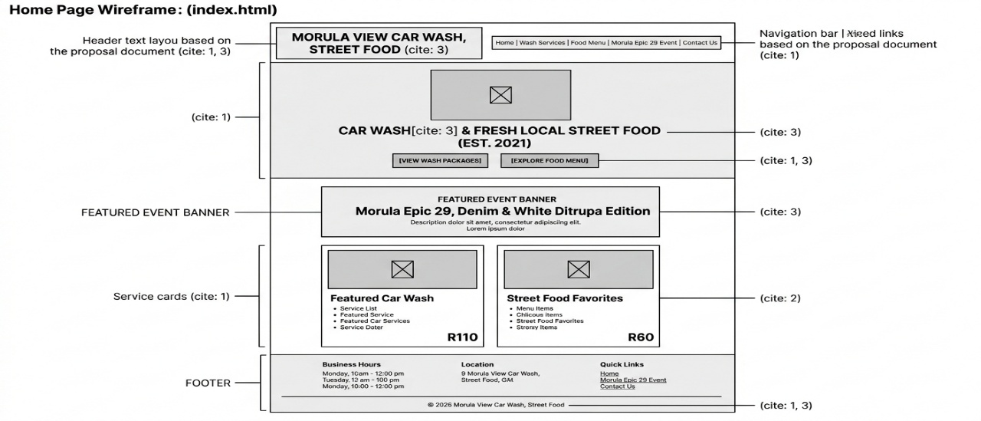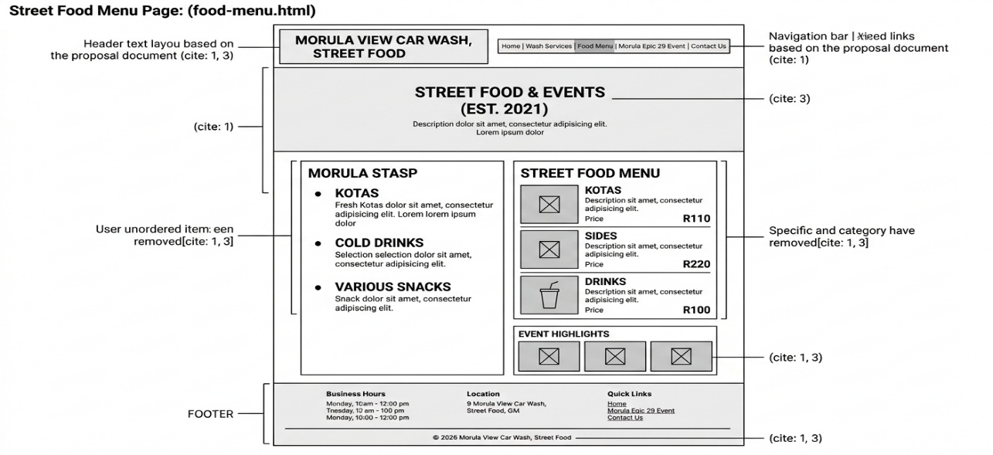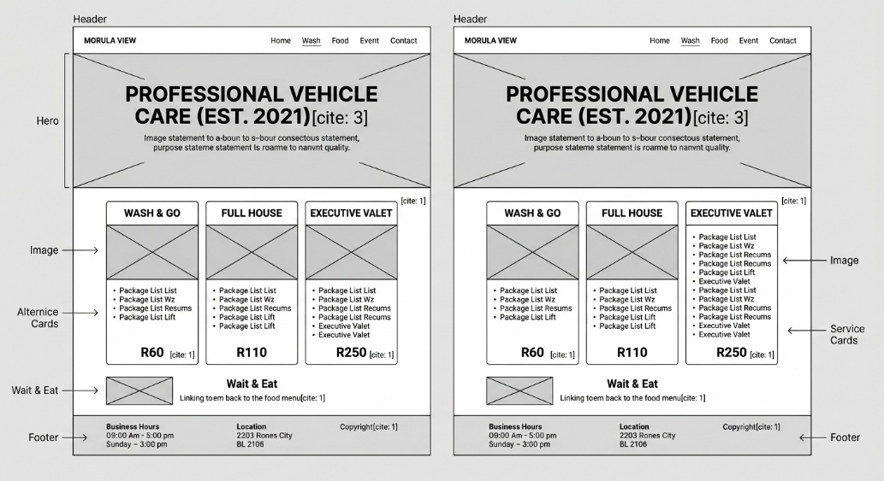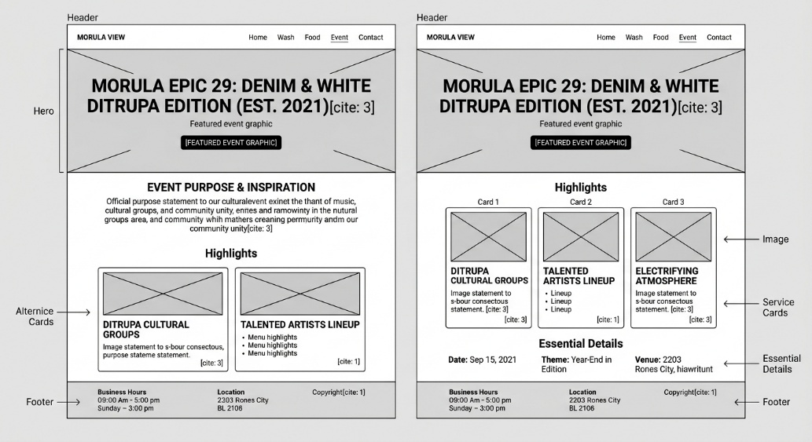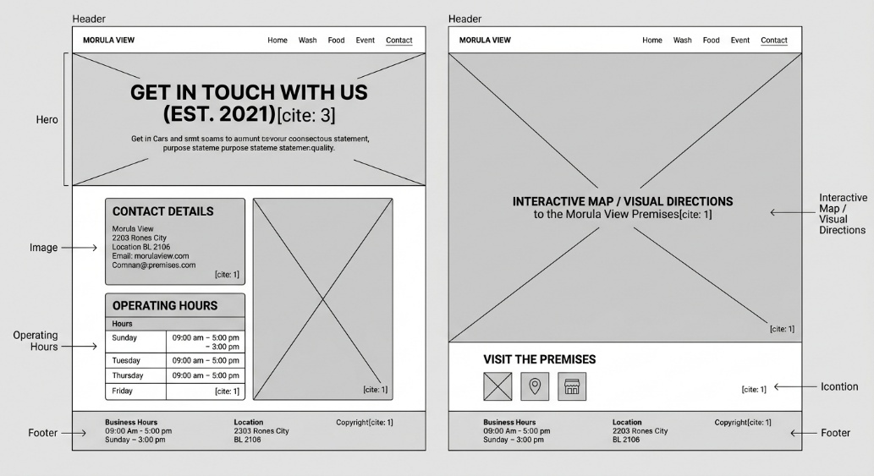

5.DESIGN AND USER EXPERIENCE
Visual Style & Mood: Clean, vibrant, welcoming, and high-energy. The visual theme combines fresh blue tones for vehicle care, warm gold for street food, and crisp white and denim blue accents reflecting the Denim & White event dress code.

Colour Palette:
Denim Blue / Slate (#1E3A8A) - Represents vehicle washing and the official "Denim & White" event theme.
Aqua Sky Blue (#0284C7) - Symbolizes fresh water and cleanliness.
Crisp White / Light Slate (#F8FAFC) - Background colour providing crisp readability and high contrast.
Typography: Clean, standard sans-serif font family (Arial / Helvetica) establishing clear visual hierarchy

6.TECHNICAL REQUIREMENTS

Category | Tool / Technology | Technical Description & Implementation Standard
Markup & Structure | Semantic HTML5 | Built strictly using standard semantic HTML5 elements (<header>, <nav>, <main>, <section>, <article>, <footer>) to construct an accessible, well-structured multi-page website without broken links
Code Editor | Visual Studio Code (VS Code) | Primary Integrated Development Environment (IDE) used for writing, formatting, and structural validation of HTML markup.
Version Control & Hosting | Git & GitHub | Local Git version control for tracking daily code changes, combined with a public GitHub repository for online code hosting, assignment tracking, and submission.
Web Browsers & Testing | Google Chrome & Microsoft Edge | Modern web browsers utilized for local file rendering, cross-page navigation verification, and multi-resolution testing.

7.TIMELINE AND MILESTONES
Phase / Task | Week 1 | Week 2 | Week 3
Topic Selection & Business/Event Research
Proposal Writing (Goals, Analysis, Event Purpose, Budget)
Sitemap Creation & Wireframe Layouts
Folder Setup & Semantic HTML5 Coding
Content Writing (Services, Food Menu, Event Info) & Navigation Linking
Testing, GitHub Commits, README & Final Submission

8.BUDGETS
Item Description | Estimated Cost | Justification / Reason
Visual Studio Code Editor | R 0.00 | Free open-source development software
GitHub Repository Hosting | R 0.00 | Free public repository tier used for submission.
Image Assets & Media | R 0.00 | Freely licensed stock images or original business photos.
Internet & Mobile Data Usage | R 150.00 | Research, downloading assets, and GitHub pushes.
Project Contingency Fund | R 200.00 | Allowance for unforeseen minor expenses.
TOTAL ESTIMATED COST | R 350.00 | Realistic estimate for Part 1 project scope

9.REFERENCES
Anglia Ruskin University, 2022. Harvard System of Referencing Guide.Available at: https://library.aru.ac.uk/referencing/harvard.htm
MDN Web Docs, 2026. HTML: A good basis for accessibility. Available at: https://developer.mozilla.org/en-US/docs/Learn/HTML/Introduction_to_HTML/Getting_started
W3C, 2023. HTML5: A vocabulary and associated APIs for HTML and XHTML. World Wide Web Consortium. Available at: https://www.w3.org/TR/html52/
W3Schools, 2026. HTML Responsive Web Design. Available at: https://www.w3schools.com/html/html_responsive.asp

